# Day 1 Activities

## Activity #1 – PI Component Knowledge Check

Now that we have reviewed the basic components of a PI, answer the multiple choice questions below.

1. What does PI stand for?
2. Payroll Interface
3. Principle Interface
4. Payroll Interconnection
5. Partner Internet
6. What is a Pay Company?
   1. A company that specializes in payroll
   2. A collection of pay groups that are specified by specific payroll vendor
7. What is the Pay Group to Pay Company Ratio (Pay Group:Pay Company)?
   1. 1 Pay Group : 1 Pay Company
   2. 1 Pay Group : Many Pay Companies
   3. Many Pay Groups : One Pay Company
   4. Many Pay Groups : Many Pay Companies
8. What must be associated with the Pay Group in order to be ran for a PI? Select all appropriate answers.
   1. Period Groups
   2. Run Category
   3. Running List
   4. Period Schedule
9. What does the “Used in Payroll Interface” Pay Group parameter need to be set to in order to run for PI?
   1. Checked
   2. Unchecked
10. What launch parameters are required to have a value when running for a PI? Select all appropriate answers.
    1. Pay Group
    2. Pay Period Selection Option
    3. Pay Group Members
    4. Exclude Members/Only Include Members
    5. Last Successful Run
    6. Basic Staffing Transaction Log Types
    7. Change Detection
    8. Full Extract With No Diff
11. What Integration Attributes must be configured after integration system creation in order for the PI to be error free? Select all appropriate answers.
    1. Include Prior Values
    2. Version
    3. Use Preferred Name when present
    4. Primary Payroll Integration
    5. Payroll Vendor
    6. First Address Usage

## Activity #2 – Create a PI

Follow the steps below to create your PI:

1. Locate the **Create Integration System** task.
2. Enter **<FirstName>_<LastName>-PI** in the System Name field.
3. Select **New using Template** option. Click the prompt and select the following: **By Integrations Template Category > Cloud Connect for Third Party Payroll > Payroll Interface**.
4. Click **OK.**
5. Enable the following additional integration services:
   * PI Personal Data Section Fields
   * PI Status Data Section Fields
   * PI Position Data Section Fields
6. Click **OK**.
7. Click **OK**.
8. Observe the Error and Alert messages in the top right hand corner of the View Integration System page. You will be able to see details by clicking on these icons.

## Activity #3a – Resolve PI errors after creation

As you noticed in Activity #2, there is 1 Error on the Integration System. The error needs to be resolved after creating an Integration System. The PI will not be able to be launched until the error is resolved.

The error message reads as follows:

*There are Integration Attributes enabled for this Integration System that are marked as "Required for Launch", but do not have a Value assigned to them. Please use the Related Menu Item (Integration System > Configure Integration Attributes) to complete the configuration. Attributes: Payroll Interface / Payroll Vendor Payroll Interface / Primary Payroll Integration Payroll Interface / Version*

In order to fix this error, follow the steps below:

1. Select the **Related** **Actions** of the Integration System
2. Navigate to **Integration System > Configure Integration Attributes.**
3. Click the **+** icon for the **Version** attribute to add a row.
4. Click the Prompt and select **25**. This is the most recent PI version.
5. Click the **+** icon for **Primary Payroll Integration** to add a row. Leave the checkbox **blank**.
6. Click the **+** icon for **Payroll Vendor** to add a row.
7. Select **UNKNOWN**.
8. Click **OK**.
9. Note that the Error is now resolved on the View Integration System page.

## activity #3b – resolve pi alerts after creation

There is still the 1 Alert on the Integration System. This alert will not prevent the PI from being launched, but it is important to resolve since it is related to security and integration setup is not complete until this is fixed.

The alert message reads as follows:

*The Integration System setup may not be complete. An Integration System User is required if the Integration System needs to be Scheduled from Workday or run as a different user than the user launching the integration. To associate an Integration System User to the Integration System, choose Workday Account > Edit from the related actions menu off the Integration System.*

In order to fix this alert, follow the steps below:

1. Search the **Create Integration System User** task.
2. Enter the User Name **<FirstName>_<LastName>-PI-User**.
3. Assign the same password as the tenant login. Leave Require New Password at Next Sign In **unchecked**.
4. Click **OK**. **Do NOT click Done on the next screen.**
5. Use the **Related Actions** icon off of the **<FirstName>_<LastName>-PI-User** and select **Security Profile > Assign Integration System Security Groups**.
6. Select **Payroll Interface System** in the Integration System Security Group to Assign field.
7. Click **OK**.
8. Click the **Payroll Interface System** security group.
9. From the **<FirstName>_<LastName>-PI** Integration System, select **Related Actions > Workday Account > Edit**.
10. Add the ISU **<FirstName>_<LastName>-PI-User** that you just created.
11. Click **OK**. Leave fields blank.
12. Click **OK**. Notice the **<FirstName>_<LastName>-PI-User** displays in the Workday Account field and the alert is now gone.

## aCTIVITY #4 – Configure the iNTEGRATION fIELD ATTRIBUTES

Enabling data section services is required before you can configure which fields will be included in the output. Since we enabled these data section services in Activity #2, we can now select which fields we want to be outputted by the PI.

1. From the **<FirstName>_<LastName>-PI-User** Integration, select **Related Actions > Integration System > Configure Integration Field Attributes**.
2. Review the fields available in the PI Personal Data Section.
3. Select the following fields in the PI Personal Data Section by selecting the **Include in Output** to be checked:
   * First Name
   * Last Name
   * Gender
   * Birth Date
   * Marital Status
   * First Address Line 1
   * First Address Line 2
   * First Municipality
   * First Region
   * First Postal Code
   * First Country

Note: When the Maximum Length is left to “0”, no length restrictions are put on that output field.

1. Review the fields available in the PI Status Data Section.
2. Select the following fields in the PI Status Data Section by selecting the **Include in Output** to be checked:
   * Pay Group
   * Staffing Event
   * Staffing Event Date
   * Hire Date
   * Termination Date
3. Review the fields available in the PI Position Data Section.
4. Select the following fields in the PI Position Data Section by selecting the **Include in Output** to be checked:
   * Business Title
   * Total Base Pay
   * Base Pay Currency
   * Base Pay Frequency
   * Organization One
5. Click **OK** and **Done.**

## Activity #5 – Configure attributes and maps for selected field attributes

Since some of the field attributes that we selected to be Included in Output had (IA) or (IM) in their descriptions, we need to configure some attributes and maps in order to get the desired output in those fields.

* Fields annotated with (IA) indicate that the field value may be controlled by an integration attribute.
* Fields annotated with (IM) indicate that the field value can be mapped using an Integration Map.

Let’s first start with the Integration Attributes:

1. Select the **Related** **Actions** of the Integration System.
2. Navigate to **Integration System > Configure Integration Attributes.**
3. Click the **+** icon for the **First Address Type** attribute to add a row.
4. Click the Prompt and select **Home**.
5. Click the **+** icon for the **Organization Type for Organization One** attribute to add a row.
6. Click the Prompt and select **Company**.

Note: The above attributes are the only attributes need to be set for the enabled Field Attributes. However, since the next activity includes running the PI as a full file, we also need to perform steps #7 and 8.

1. Click the **+** icon for the **Extract All Payee Data** attribute to add a row.
2. Select **Checked**.
3. Click **OK.**

Next, let’s configure the Integration Maps so that for the Gender field, M gets outputted for Male workers and F gets outputted for Female workers.

1. Select the **Related** **Actions** of the Integration System.
2. Navigate to **Integration System > Configure Integration Maps.**
3. Click the **+** icon for the **Gender** map to add a row **twice**.
4. Click in the first Internal Value Prompt and select **Male**.
5. Enter **M** into the first External Value Prompt.
6. Click in the second Internal Value Prompt and select **Female**.
7. Enter **F** into the second External Value Prompt.
8. Click **OK.**

## Activity #6 – Run the PI

Now that the error is resolved and the PI is set up, it is time to run the PI.

1. Click the **Related Actions** off of the Integration System.
2. Navigate to select **Integration** > **Launch/Schedule**.
3. Click **OK**.
4. Enter the following Integration Criteria:
   * Pay Group = WCC Third Party – Green Planet Acquisition
   * Pay Period Selection Option = Use Pay Period For Current Date
5. Click **OK** to launch the integration.
6. Click **Refresh** until the **Status is Complete**.

## Activity #7 – Navigate to the Integration Event

If for some reason you do not keep the integration launch window open and need to navigate to the integration event, follow the steps below to navigate back to the integration event.

#### Method #1 – Through the integration system

1. Search for the integration system name in the search bar.
2. Click on the **Integrations** search category.
3. Select the **Related Actions** of the integration system.
4. Navigate to **Integration System > Integration Events.**
5. Here you can select different parameters to narrow down the integration events. For now, just click **OK**.
6. Select the Integration Event Link under the **Integration Event** column.

#### Method #2 – through the integration events REPORT

1. Search for the **Integration Events** report. You will see it in the drop down so you can select it without hitting <Enter>.
2. Here you can select different parameters to narrow down the integration events. For now, only enter the Integration System Name under the **Integration System** field.
3. Click **OK**.
4. Select the Integration Event Link under the **Integration Event** column.

## Activity #8 – Files on the Integration Event

Now that you have navigated to the Completed integration event, let’s look at what is outputted on the integration event.

1. Click on the “Output Files” tab on the Integration Event.
2. You will see a total of 6 items.
   * Compressed ZIP file for the Pay Group:

MessagesAudit-WCC_Third_Party_-_Green_Planet_Acquisition_1.zip

* + Data Changes Audit
  + Diagnostic Audit
  + Compressed ZIP File for the System Info:

MessagesAudit-SystemInfo_1.zip

* + Payroll Extract
  + PI Common Output File

1. Open these and look at the format and content of each of these.

Note: Keep this integration event and files available since we will be referencing them again in a later activity.

1. Notice that the completed integration event has a lot of warnings on it. All of the warnings are of the similar layout:

*No value output from applying empty integration map Marital Status for Marital Status. The following targets are affected: <Worker>*

1. Look at the first employee in warnings list – Kim Slater- in the Payroll Extract XML output. Note that there is no Marital Status extracted in the Personal Data Section.

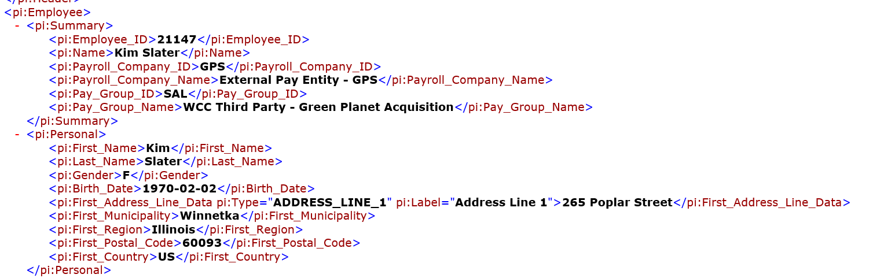

1. Search for Kim Slater in the search bar and navigate to her profile.
2. Click on the Personal tab.
3. Notice that Kim has a Marital Status of Married (United States of America) that should be outputted in the Payroll Extract.
4. Note that Kim’s Gender on her Profile is Female, but on the Payroll Extract, the Gender field is outputting F. This is because of the map setup in the previous activity.
5. Click on the Contact tab.
6. Notice that the address in the Payroll Extract XML matches the address under the Home Contact information, not Work. This is due to the attribute set up in the previous activity.

## Activity #9 – Fix the warnings on the integration event

By reading this warning, it appears that there is an issue with the map for Marital Status. Let’s look at the field attribute:

1. From the **<FirstName>_<LastName>-PI-User** Integration, select **Related Actions > Integration System > Configure Integration Field Attributes**.
2. If we look at the **Marital Status** field in the PI Personal Data Section, it has a (IM) denoted in the description.

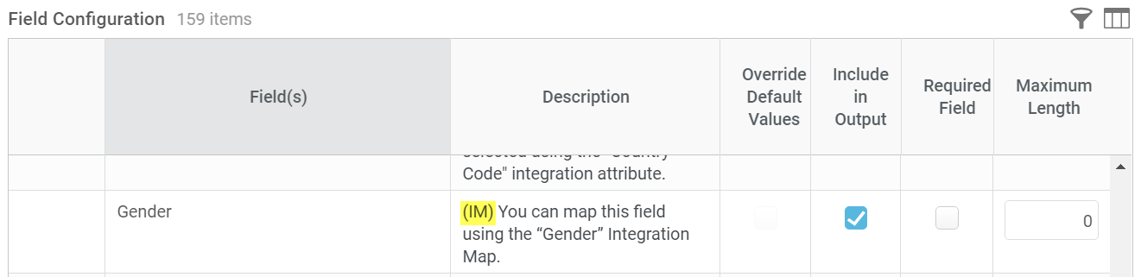

This denotation along with the warning indicates that a map needs to be configured for Gender. Let’s say for this example that the vendor wants the following to be outputted:

* S for Single
* M for Married or Partnered
* D for Divorced, Separated, or Widowed

1. Click **Cancel.**
2. Select the **Related** **Actions** of the Integration System
3. Navigate to **Integration System > Configure Integration Maps.**
4. Click the **+** icon for the **Marital Status** map to add a row.
5. Click in the first Internal Value Prompt and select **United States of America > Single (United States of America)**.
6. Enter **S** into the first External Value Prompt.
7. Click the **+** icon for the **Marital Status** map to add a row again.
8. Click in the first Internal Value Prompt and select **United States of America > Married (United States of America)** and **Partnered (United States of America)**.
9. Enter **M** into the first External Value Prompt.
10. Click the **+** icon for the **Marital Status** map to add a row again.
11. Click in the first Internal Value Prompt and select **United States of America > Divorced (United States of America), Widowed (United States of America),** and **Separated (United States of America)**.
12. Enter **D** into the first External Value Prompt.
13. Click **OK.**

## Activity #10 – Rerun pi with no warnings

1. Click the **Related Actions** off of the Integration System.
2. Navigate to select **Integration** > **Launch/Schedule**.
3. Click **OK**.
4. Enter the following Integration Criteria:
   * Pay Group = WCC Third Party – Green Planet Acquisition
   * Pay Period Selection Option = Use Pay Period For Current Date
5. Click **OK** to launch the integration.
6. Click **Refresh** until the **Status is Complete**.
7. Notice how there are now only 1 warnings on the completed integration event.
8. Open the Payroll Extract and navigate to Kim Slater.
9. Kim now has the Marital Status field in the output.

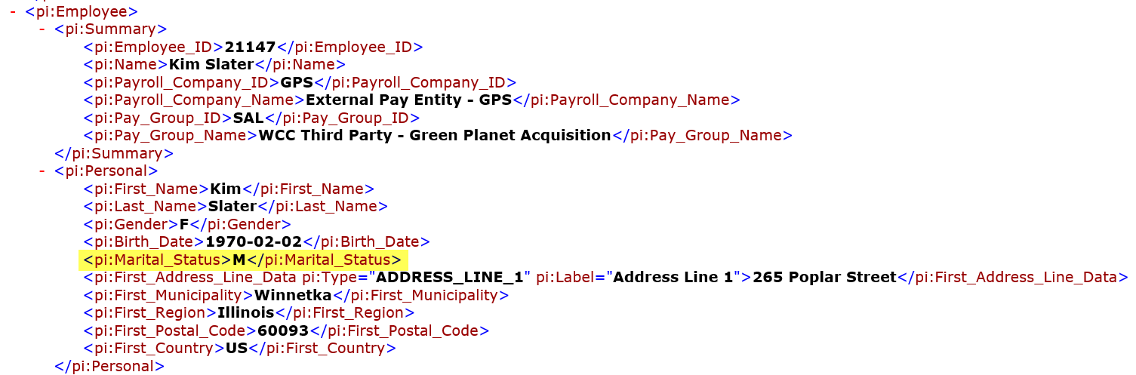

**Challenge Question: What is causing the remaining 1 warning?**